**CelDial: Case Study Analysis**

**Group 6**

Bhaskar Narayan

Shreyas Harle

**INTRODUCTION:**

CelDial Corporation started as a manufacturer of cellular telephones. It quickly expanded to include a broad range of telecommunication products. As the demand for, and size of, its suite of products grew, CelDial closed down distribution channels and opened its own sales outlets. Its main focus was firmly on expansion, but the corporation put little effort into measuring the effectiveness of the expansion. As growth started to level, the company refocused their priorities on their performance. In doing so, CelDial realised the necessity of analysing the cost and revenue generated, to help them understand their growth and performance.

**OBJECTIVE:**

1. Operational System:

To create a collection of data that users could effectively analyze.

2. Data warehouse System:

To create a data warehouse to facilitate the analysis of cost and revenue data for products manufactured and sold by CelDial.

After consideration of the potential costs and benefits, management agreed.

**SCOPE OF THE PROJECT:**

The project shall be limited to direct costs and revenues associated with products. Currently, CelDial’s manufacturing costs cannot be allocated at the product level. Therefore, only component costs can be included. At a future time, rules for allocation of manufacturing and overhead costs may be created, so the data warehouse should be flexible enough to accommodate future changes. IT created a team consisting of one data analyst, one process analyst, one manufacturing plant manager, and one sales region manager for the project.

**UNDERSTANDING & ANALYZING REQUIREMENTS:**

Before we move to the analysis part let’s see about the business needs and those are as follows:

· Life cycle of a product

· Anatomy of a sale

· Structure of the organization

· Defining cost and revenue

Analysis part:

1. Life cycle of a Product:

At the moment, CelDial has 300 models of products. This number is fairly constant as the rate of new models being created approximately equals the rate of old models being discontinued. New products are added to the company records when manufacturing process is completely defined and approved. Approximately 10 models per week experience a cost or price change. Additional components are added to basic sets to create specific models. Work order is created when quantity falls below a predetermined level. Manufactured models are stored at the manufacturing plant until it is requested by the sales outlet. Data about a discontinued model is kept on file for six months from the date of last sale (or discarding) of that model. Discounting on a model is decided if needed. If eligible, the salesperson gives discount if customer buys large quantity. In retail stores, the store manager must approve of a discount for it to apply.

2. Anatomy of a sale:

There are two types of sales outlets: corporate sales office and retail store.

A corporate sales office sells only to corporate customers. Corporate customers are charged the suggested wholesale price for a model unless a discount is negotiated. One of CelDial’s 30 sales representatives is assigned to each corporate customer. CelDial currently serves 3000 corporate customers. A customer can place orders through a representative or by phoning an order desk at a corporate sales office. Orders placed through a corporate sales office are shipped directly from the plant to the customer. A customer can have many shipping locations. A corporate sales office, on average, creates 500 orders per day, five days per week. Each order consists of an average of 10 product models.

A retail store sells over the counter. Unless a discount is negotiated, the suggested retail price is charged. Although each product sale is recorded on an order, the company does not keep records of customer information for retail sales. A store can only order from one manufacturing plant. The store manager is responsible for deciding which products will be stocked and sold from his or her store. A retail store, on average, creates 1000 orders per day, seven days per week. Each order consists of an average of two product models.

3. Structure of the organization:

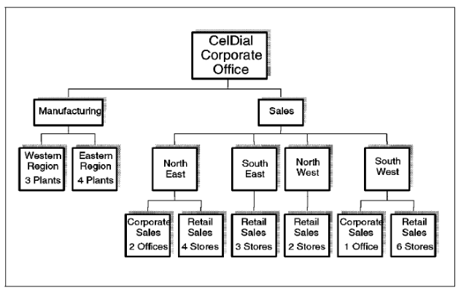

4. Defining cost and revenue:

The following formula was used to obtain the total cost of a product:

**∑** (**C** x **N**) = **T**

Where:

**C**:Cost of each component

**N**: Number of components

**T**: Total cost of model

The total revenue for the model is the sum of results of all order lines that sell the model.

The cost of that unit of the model could not be definitively identified because the cost of a component is only used to calculate a current value of the inventory. Actual cost is recorded only in the company's financial system, with no reference to the quantity manufactured.

Therefore, and based on the fact that component costs changed infrequently and by small amounts, the team defined this rule: The revenue from the sale of a model is always recorded with the current unit cost of the model, regardless of the cost of the model at the time it was manufactured.

**DESIGN APPROACH:**

**Conceptual Design**

* Choose the Data Mart: Cost, Revenue
* Declare the Grain: Time(week, month) , Outlet(corporate, retail)
* Choose the Dimensions: Plant Details, Manufacturing Plant, Regions, Component Details, Inventory, Corporate Sales, Retail Sales, Order Line
* Choose the Facts: Cost, Revenue

**Entity Details**

|  |  |
| --- | --- |
| **ENTITY** | **FACT/DIMENSION** |
| Cost | Fact |
| Plant Details | Dimension |
| Manufacturing Plant | Dimension |
| Regions | Dimension |
| Component Details | Dimension |
| Inventory | Dimension |
| Revenue | Fact |
| Corporate Sales | Dimension |
| Retail Sales | Dimension |
| Order Line | Dimension |

|  |  |
| --- | --- |
| **ENTITY** | **NUMBER OF ATTRIBUTES** |
| Cost | 9 |
| Plant Details | 4 |
| Manufacturing Plant | 3 |
| Regions | 3 |
| Component Details | 6 |
| Inventory | 5 |
| Revenue | 11 |
| Corporate Sale | 5 |
| Retail Sales | 4 |
| Order Line | 5 |

**Logical Design**

**Required Trace Ability Matrix**

|  |  |  |  |  |
| --- | --- | --- | --- | --- |
| **SUBJECT AREA** | **KEY BUSINESS MEASURES** | **GRANULARITY** | **DIFFERENT KIND OF ANALYSIS** | **DIMENSIONS INVOLVED IN ANALYSIS** |
| **REVENUE** | Total revenue  Total quantity sold  Discount | Week, month  Outlet type: retail, corporate  Product type, model | * Total revenue for each model, for each region. * Percentage of products eligible for discounting. * Percentage of products sold based on outlet type. * No sales recorded by outlet type last month | Time  Customer  Product  Orders  Employees |
| **COST** | Total cost  Total Quantity  Produced  Reorder Level | Week, month  Product type, model | * Average quantity on hand and reorder level by manufacturing plant * Total cost for each model type, for each region | Product  Manufacturing  Time |

|  |  |  |  |  |  |  |
| --- | --- | --- | --- | --- | --- | --- |
| **Fact**  **Dimension** | **Total Qty sold** | **Total Qty produced** | **Reorder Level** | **Total Revenue** | **Total Cost** | **Discount** |
| **Time** | X | X | X | X | X | X |
| **Customer** |  |  |  |  |  |  |
| **Order** | X |  | X | X |  |  |
| **Employee** |  |  |  |  |  |  |
| **Product** | X | X | X | X | X | X |
| **Manufacturing** |  | X | X |  | X |  |

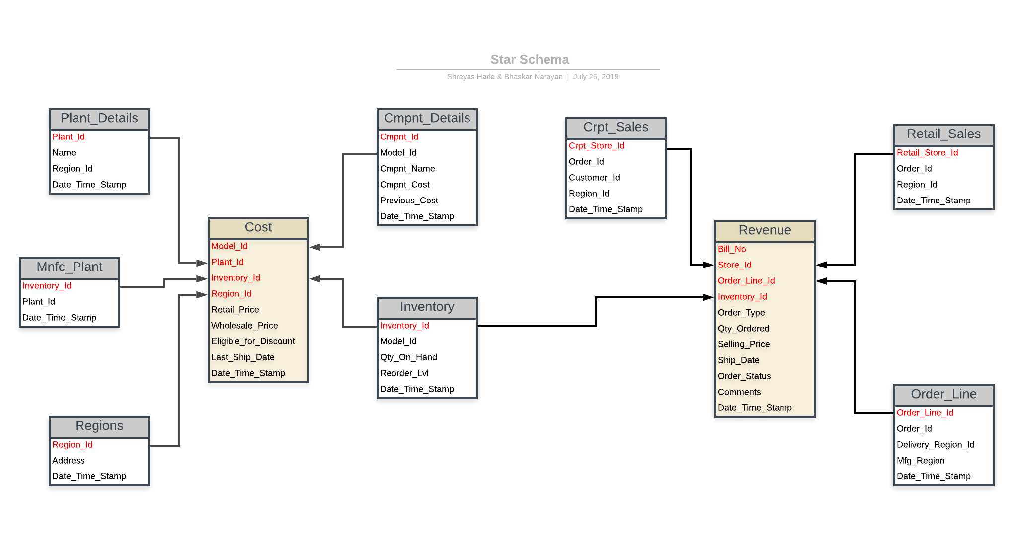

**Physical Design**

|  |  |
| --- | --- |
| **Data Usage** | **Standard** |
| **Ship_Date** | DATE |
| **Plant_Id** | NUMBER |
| **Plant_Name** | VARCHAR2(10) |
| **Region_Id** | NUMBER(8) |
| **Address** | VARCHAR2(20) |
| **Order_Line_Id** | NUMBER(5) |
| **Mfg_Region_Id** | NUMBER(8) |
| **Deliviery_Region_Id** | Number |
| **Order_Id** | NUMBER(8) |
| **Inventory_Id** | NUMBER(8) |
| **Order_Type** | VARCHAR2(10) |
| **Model_Id** | NUMBER(8) |
| **Selling_Price** | NUMBER(8) |
| **Qty_Ordered** | VARCHAR2(20) |
| **Order_Status** | VARCHAR(20) |
| **Comments** | VARCHAR(20) |
| **Qty_On_Hand** | NUMBER(8) |
| **Recorder_Level** | NUMBER(8) |
| **Retail_Store_Id** | NUMBER(8) |
| **Corporate_Store_Id** | NUMBER(8) |
| **Customer_Id** | NUMBER(8) |
| **Customer_Name** | VARCHAR2(20) |
| **Component_Id** | NUMBER(8) |
| **Component_Name** | NUMBER(8) |
| **Component_Cost** | NUMBER(8) |
| **Previous_Cost** | NUMBER(8) |
| **Wholesale_Price** | NUMBER(8) |
| **Number_of_Componnets** | NUMBER(8) |

**Operational to Dimensional Model:**

**Map:**Two fact tables are created as follows:

1. Cost Fact Table
2. Revenue Fact Table

**Cost Fact Table:**

This fact table consists of 5 dimensions: plant_details, manufacturing plant, regions, inventory, and component details. The transitions for this fact table are model_id, qty_on_hand, plant_id and inventory_id that takes care of the reordering process as the quantity on hand goes below a predefined threshold.

**Revenue Fact Table:**

This fact table consists of 3 dimensions: Crpt_Sales, Retail_Sales and Order_Line. The transition for this fact table consists of cost, revenue, quantity_sold, order_id and retail_store_id, and crpt_store_id. This fact table looks into the cost and revenue aspects of the sales done in a particular time span, the discount percentage based on the quantity of order. The fact table also keeps a tab of quantity sold for every model.